Email Etiquette

Sending an email to National Board
- ATTN: __________ (Position Your are Emailing)
- Reminders:
  - Be respectful
  - Allow 48 hours for a response without following up
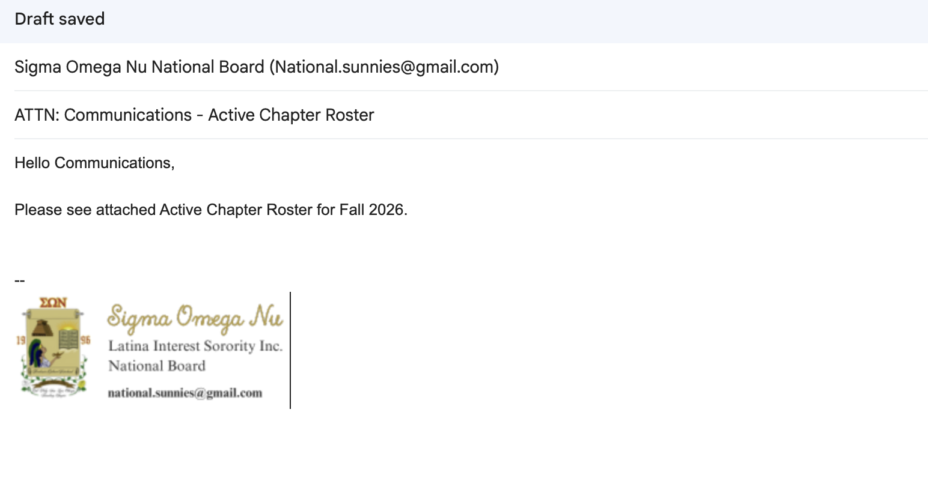
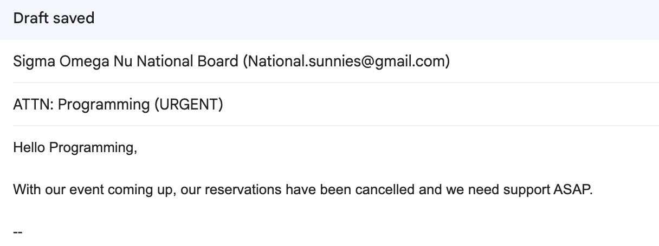
  - If urgent, indicate in your subject line

